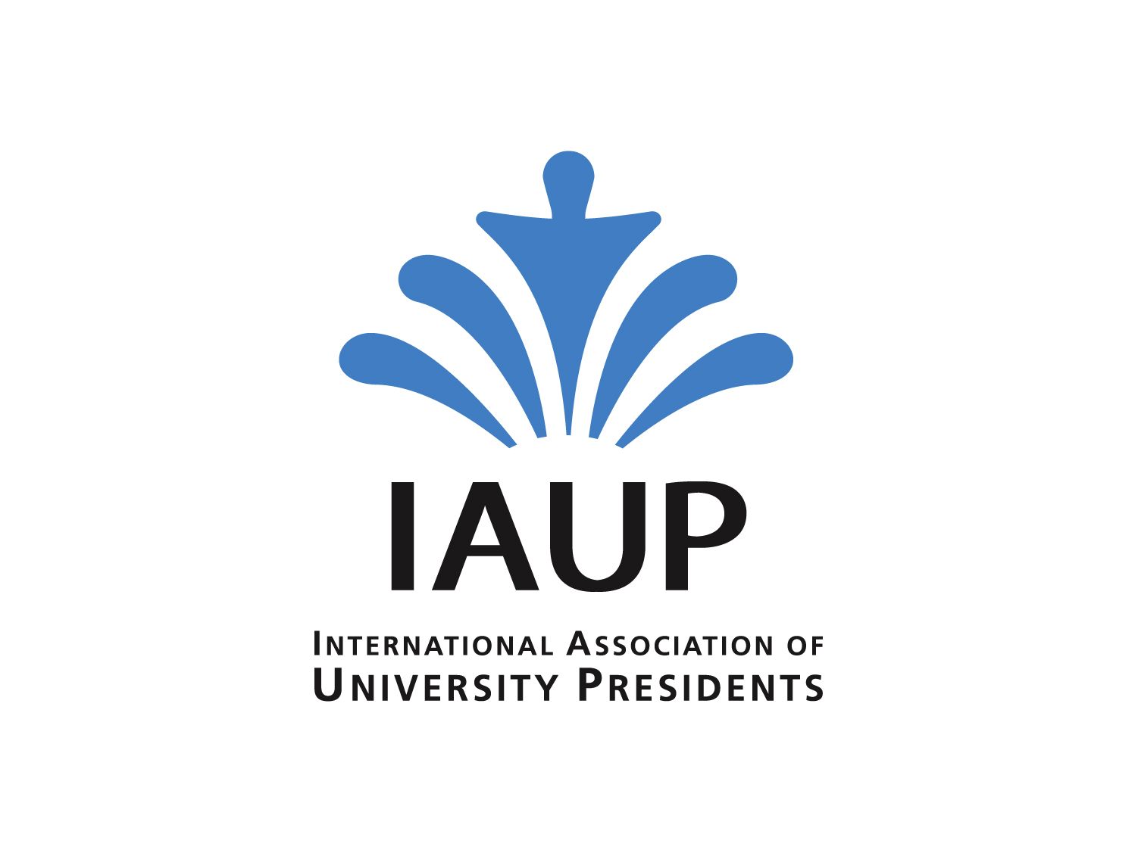**Request**

**International Faculty Achievement Award  
International Association of University Presidents** www.iaup.org

IAUP offers its members the International Faculty Achievement Award that will recognize a faculty member for extraordinary achievement in curriculum development, service, and teaching to prepare world citizens. The award is a certificate by IAUP that includes a faculty members name and institution, as well as the signatures of the IAUP president and IAUP member.

Awards are printed individually and come in a handsome IAUP folder. Each member president can request one award per year. There is no monetary benefit with the award, just a certificate that university leaders can use by itself or in combination with other benefits that they provide through their home institutions.

Requests for awards can be emailed to IAUP’s Secretary-General [office@iaup.org](mailto:office@iaup.org). Each IAUP member is limited to one request per year.

|  |  |
| --- | --- |
| **Recipient’s name:** | **Year of award:** |
|  |  |

|  |  |
| --- | --- |
| **IAUP member’s name:** | **Name of institution:** |
|  |  |

|  |
| --- |
| **Citation to appear on certificate (20 or fewer words):** |
|  |

|  |  |
| --- | --- |
| **Address to which certificate should be sent:** | **Date upon which certificate is required:** |
|  |  |

|  |
| --- |
| Instructions |
| **Please submit this form to IAUP Secretary-General, at:** [**office@iaup.org**](mailto:office@iaup.org)    **IMPORTANT: Please submit this form at the latest end of October – 31th October**  **AND attach a copy of the CV (in English!) of the recipient for our files** |