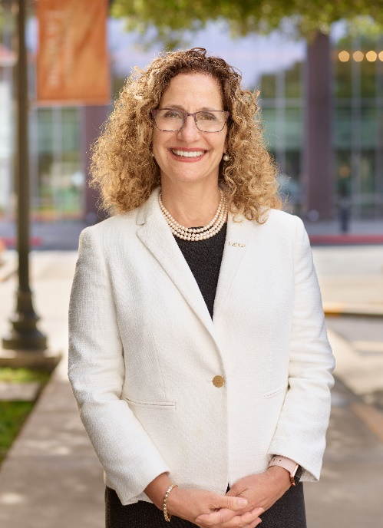
Dr. Devorah Lieberman is the 18th president of the University of La Verne, a nationally ranked and Carnegie-recognized private institution for civic and community engagement. Located in Southern California, the University of La Verne was founded in 1891 and educates approximately 8,000 students. Serving as president since 2011, she demonstrates unwavering commitment to the mission and vision of the University of La Verne as well as constant dedication to its remarkable students.
President Lieberman’s vision supports the university values and mission of delivering quality academic programs at the undergraduate, masters and doctoral levels. Some of her primary accomplishments include: establishing a College Health and Community Well Being; instituting the La Verne Experience; raising $128 million in the largest comprehensive campaign in institutional history; significantly increasing funding for student scholarships; expanding the international student population; increasing the number of named colleges, endowed deans, and endowed faculty positions; and, significantly increasing the institutional endowment.

President Lieberman is currently Chair-Elect of the New American Colleges & Universities (NAC&U), and serves on the Boards of the Coalition of Urban and Metropolitan Universities (CUMU), the Association of Independent California Colleges and Universities (AICCU), Casa Colina Centers for Rehabilitation, La Plaza de Cultura y Artes, the L.A. County Fair Board, and the LA Chamber of Commerce.

Dr. Lieberman has broadly published books and articles in higher education literature on the topics of intercultural communication, faculty development, diversity, and institutional transformation. Awards she received include the Oregon Council for Hispanic Advancement’s “Si Se Puede Award”, the Carnegie Foundation “Oregon Professor of the Year”, the ACE “Bringing the World into the Classroom” National award, the Student Union President of the Year, and, the Ellis Island Award.

Prior to her presidency at the University of La Verne, she was Provost at Wagner College on Staten Island and Vice Provost and Professor of Communication Studies at Portland State University.

She graduated with her Ph.D. from the University of Florida; with her MA from San Diego State; with her BA from Humboldt State, and her AA from Mt. San Antonio College.

