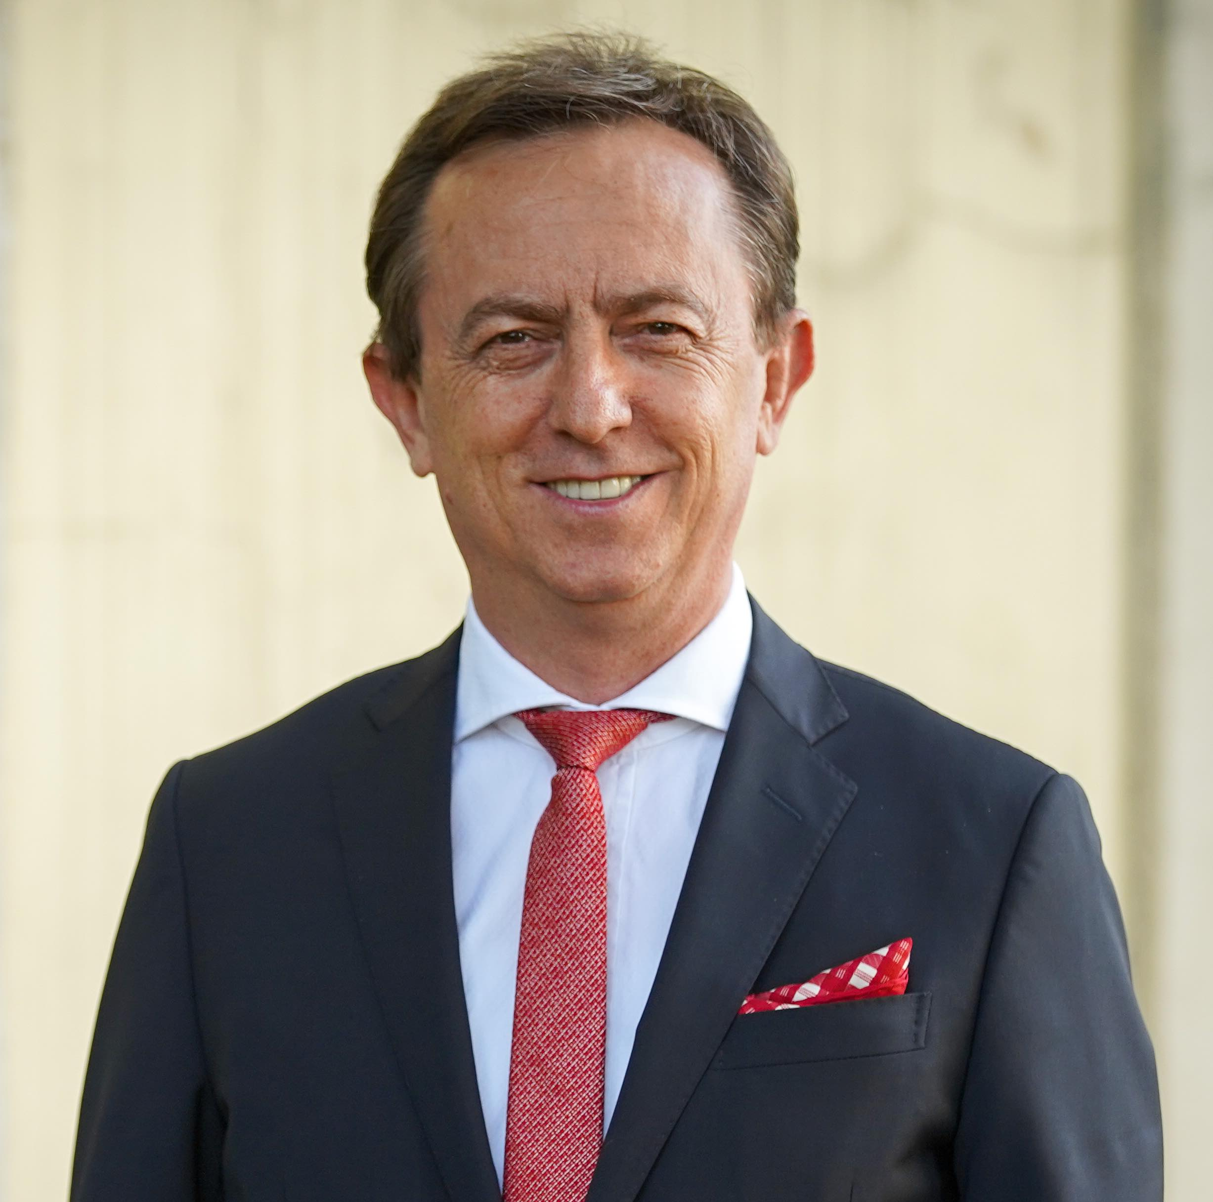

Muhammed Sahin, Professor
MEF University, Rector/President, Istanbul, Turkey
sahin@mef.edu.tr, www.mef.eud.tr, www.muhammedsahin.org

He was born in Turkey in 1965. He graduated from the Department of Geomatics Engineering, Faculty of Civil Engineering, Istanbul Technical University (ITU) in 1987. He received his master's degree from University College London in 1991, and his PhD degree from University of Newcastle, UK in 1994. He became a tenured Professor in the Department of Surveying at ITU in 2002. He was the president of ITU between 2008 and 2012. He was also a member of the Board of Directors of CESAER (Conference of European Schools for Advanced Engineering Education and Research) between 2009 and 2012.
He is the founding rector of MEF University located in Istanbul, Turkey. MEF University was established in 2012 as the world's first and only fully flipped university (www.mef.edu.tr/en). He has co-authored three books : The Flipped Approach to Higher Education, in 2016, The New University Model: Scaling Flipped Learning in Higher Education, in 2019, and The New University Model: Flipped, Adaptive, Digital and Active Learning (FADAL), also in 2019.

