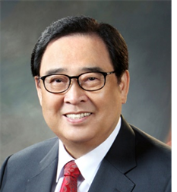

Se-Ung Lee

Se-Ung Lee

Se-Ung Lee

Seoul, Korea

Founder and Board Chair of Seoul Cyber University.
Served as Chairman & CEO of Hankuk Glass Industries Co. Ltd., Korea Industrial Gases Co. Ltd.
Served as Member of Presidential Commission on Education Reform of Korea.
Served as Board Chair Sookmyung Women’s University.
Former President of the National Red Cross Korea.
Former Presidential advisor on Unification of Korean Peninsula.
Honorary Board Chair of the Seoul Arts Center.
Highest Order of Civil Merit (Mugunghwa) for Outstanding Meritorious Service in the Area of Education and Arts, Republic of Korea.
Doctor of Economics.
Author of Global Management and Strategy (1998), Color of Thoughts (2013)

